# E-Bank Documentation

*In this tutorial, we are going to create a banking software – E-Bank, Online banking system. After we are done with our application, we are going to have the following functionality: User register, login, logout, a logged in user can create a bank account/s, deposit and withdraw given amount, transfer money to another user’s bank account, get information about transactions.*

**Chapters 3 is for advanced users. There’s a skeleton which you can use and start from chapter 4.**

## Problem

At the end the **E-Bank** should looks like:

* Guest Index:

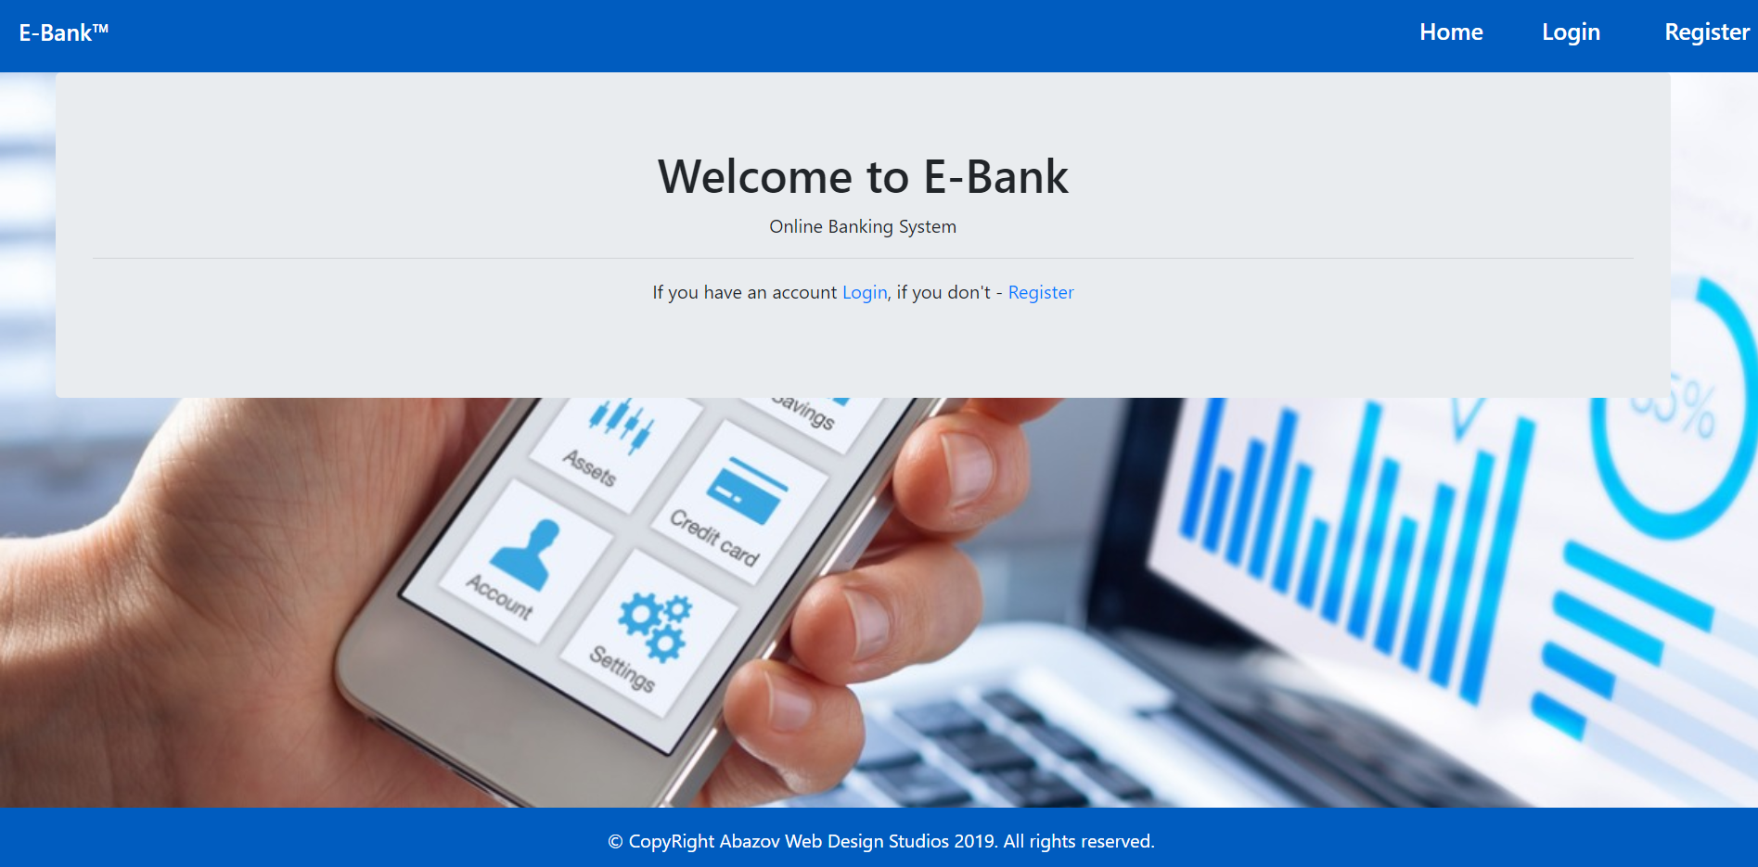

* Register view:

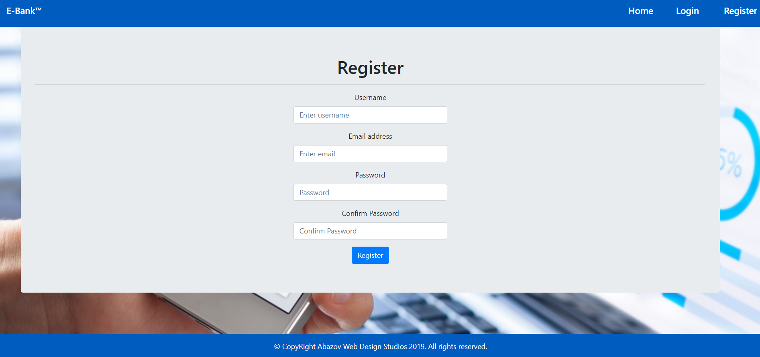

* Login view:

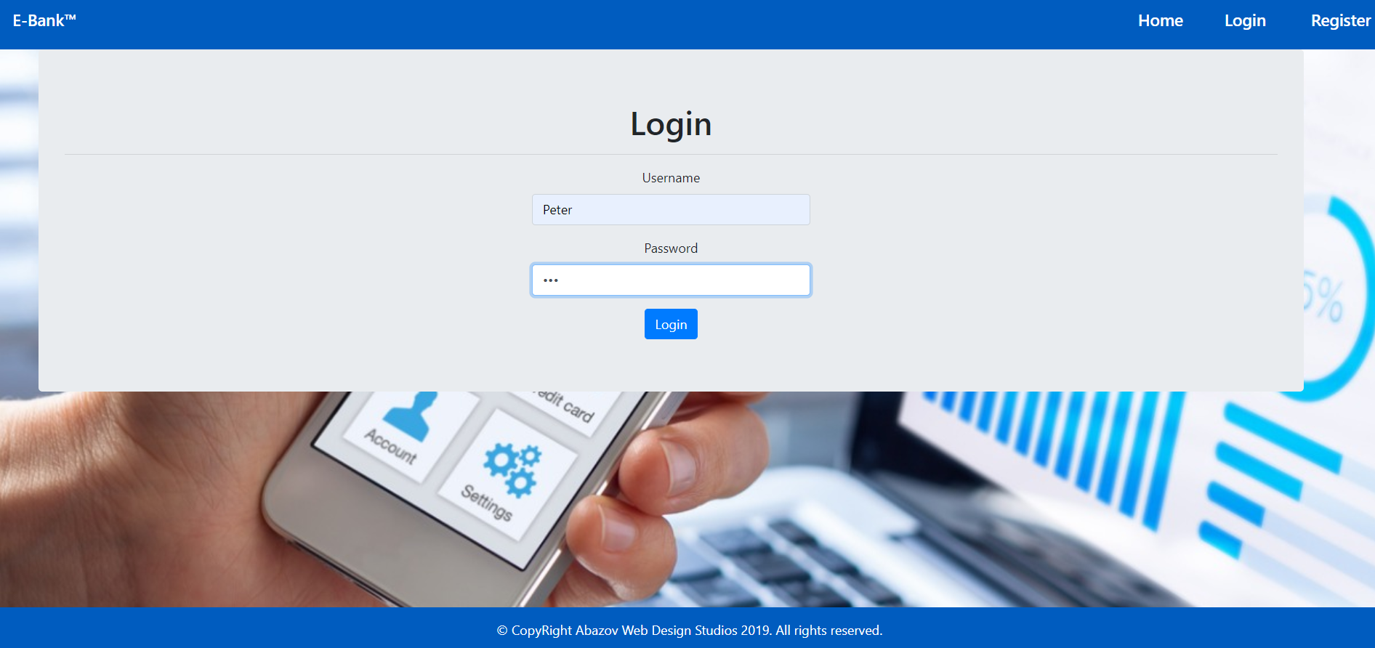

* User Logged In Index view:

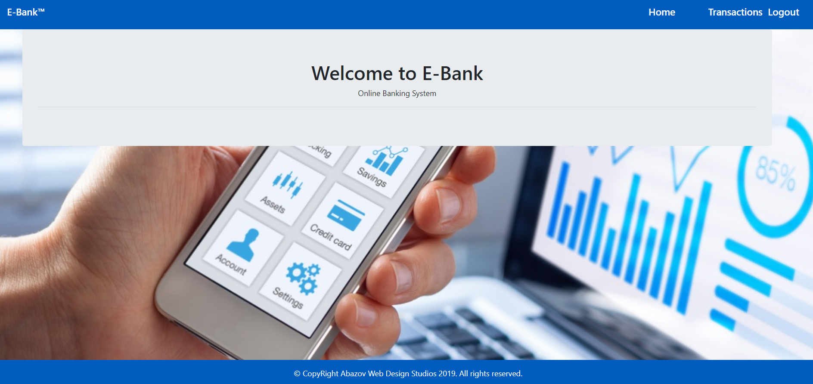

* User Logged In Home view:

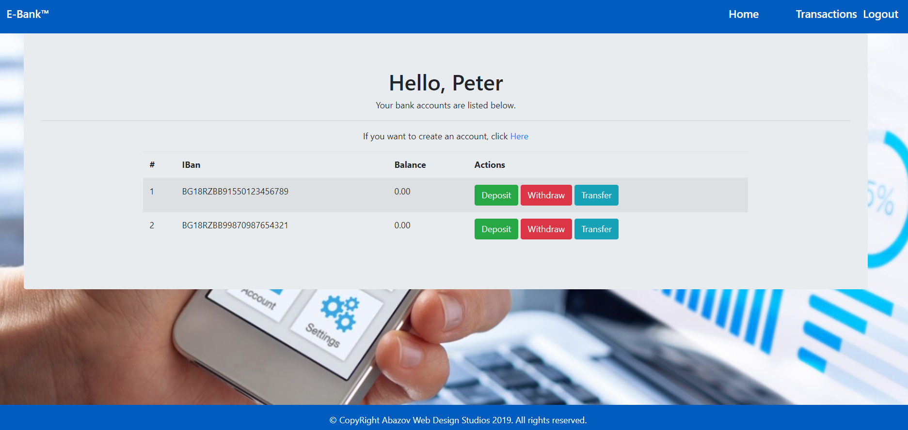

* Create account view:

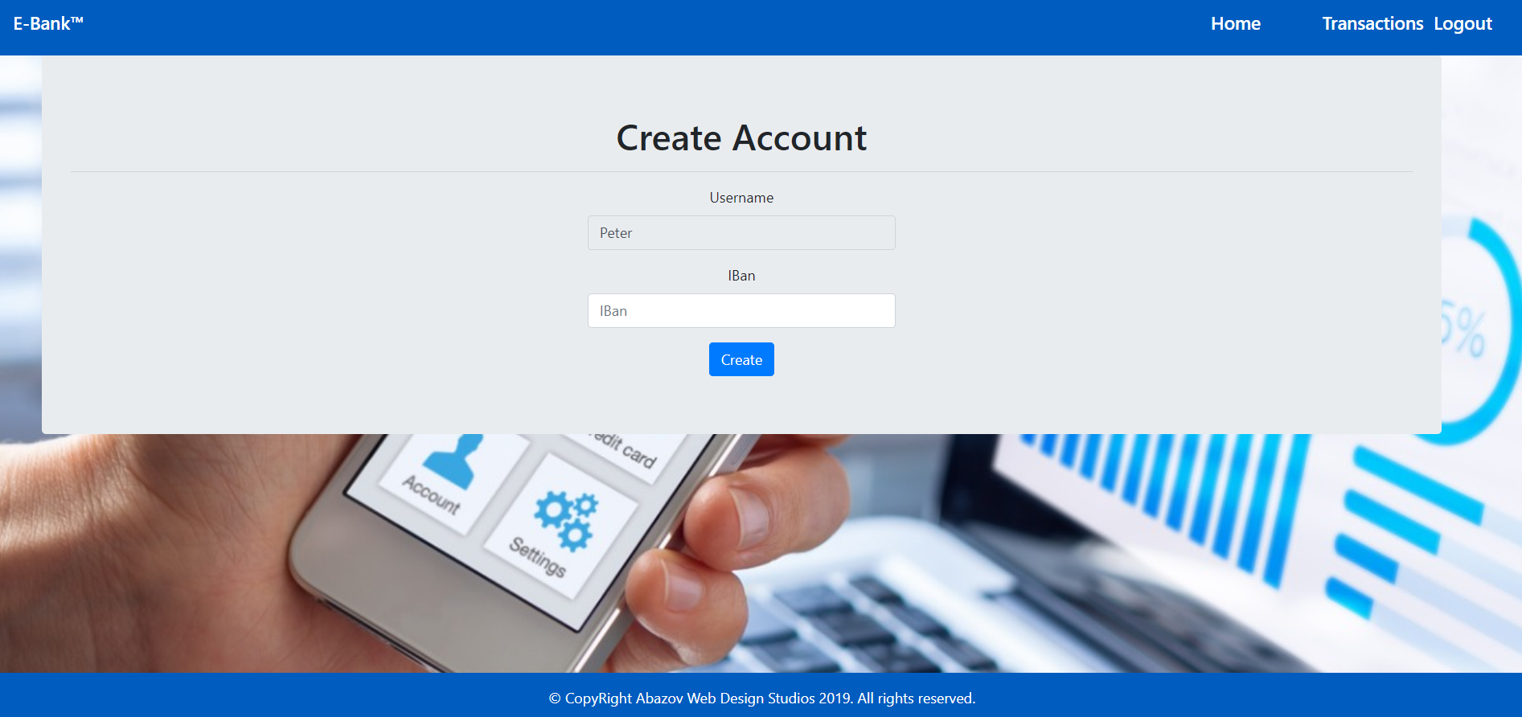

* Deposit view:

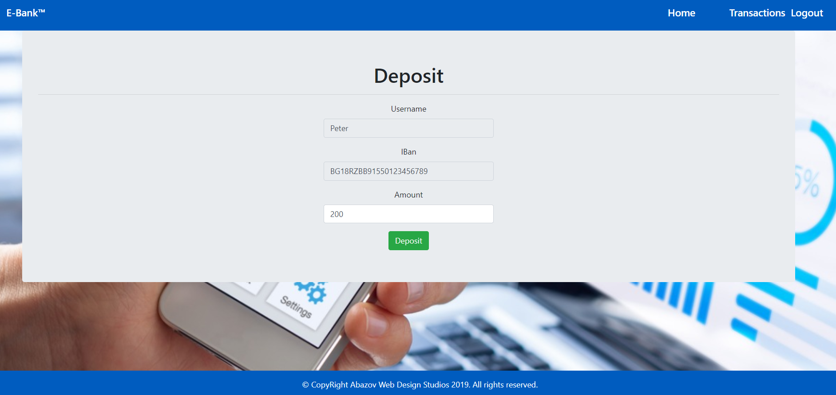

* Withdraw view:

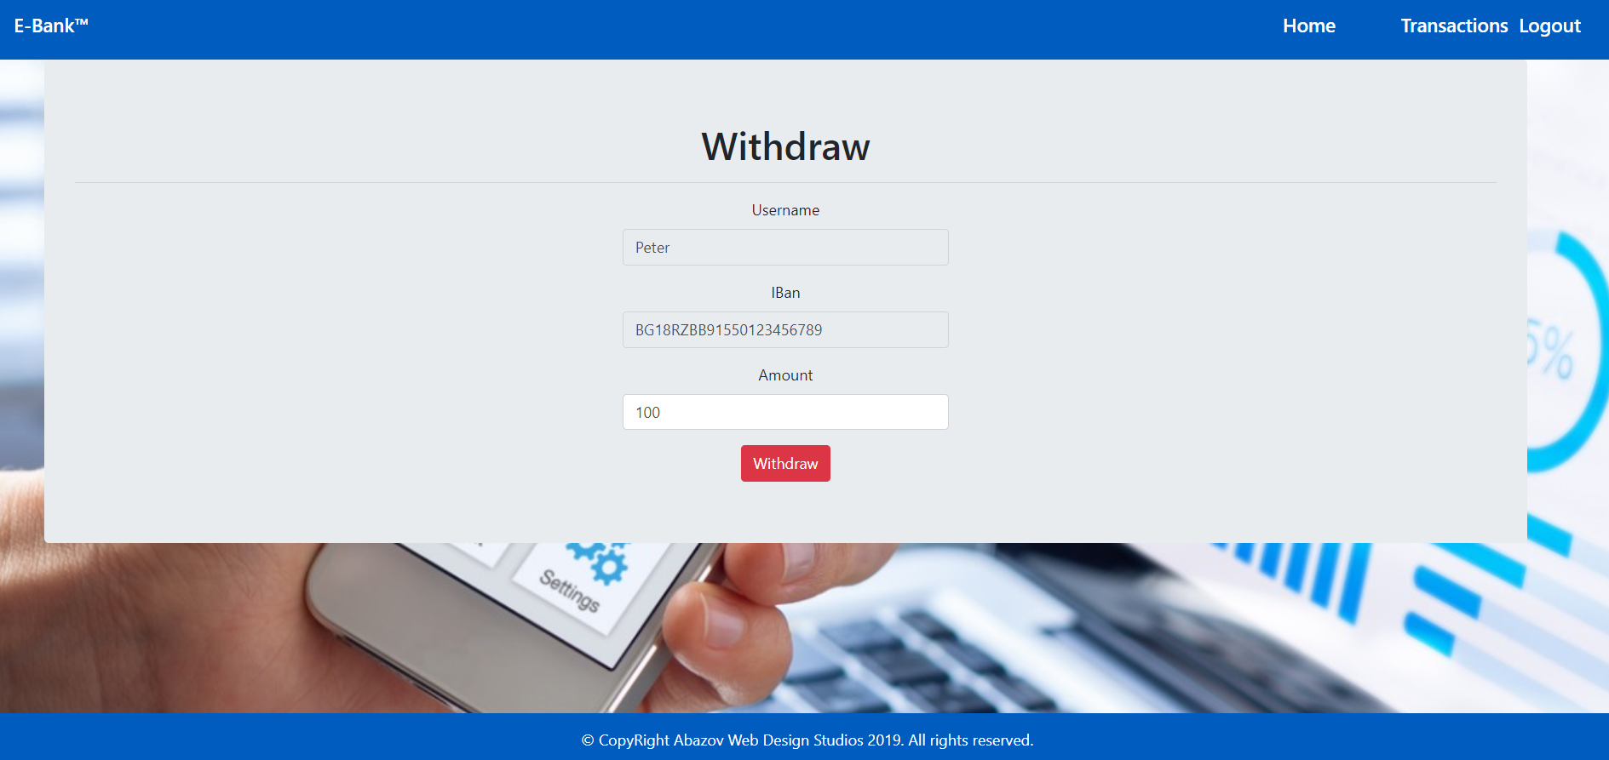

* Transfer view:

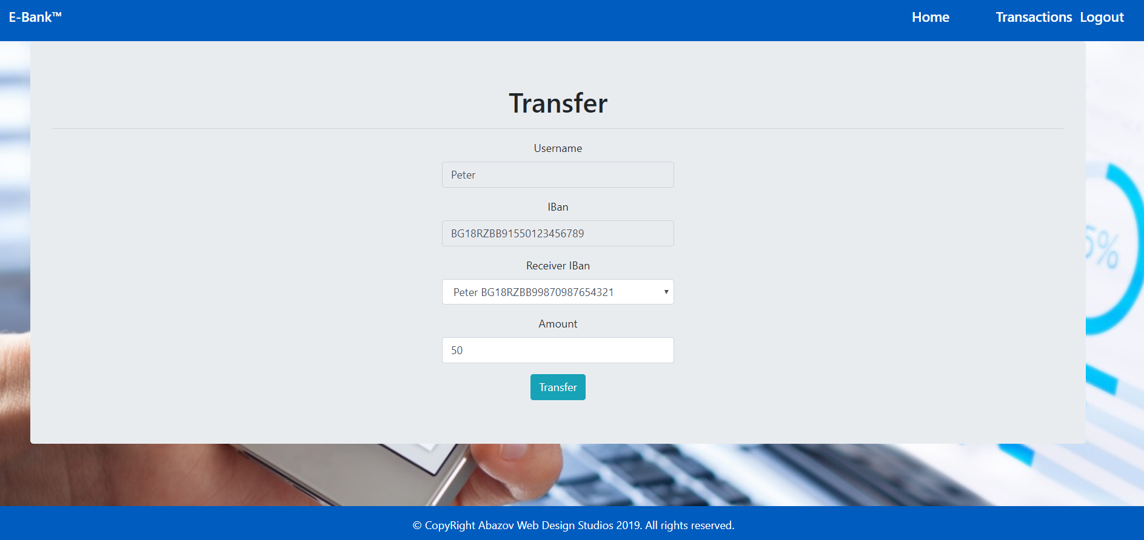

* Transactions view:

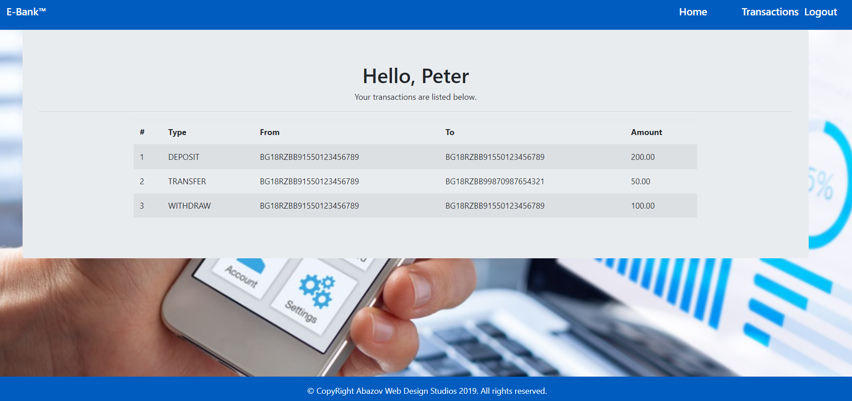

## What Are We Going to Use?

### IntelliJ

You probably already have it but if you don’t you can download it from here <https://www.jetbrains.com/idea/download/#section=windows> .

### Spring Framework

You don’t need to install anything, but if you are interested you can read more at <https://en.wikipedia.org/wiki/Spring_Framework>.

## Setting up the Project

First, we start **IntelliJ** and click on "**Create New Project**".

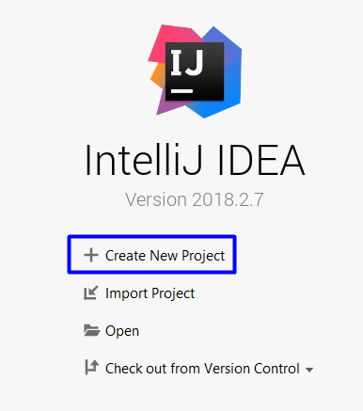

Next, we select "**Spring Initializr"**. After that, we must check out **Java** version and click **Next**.

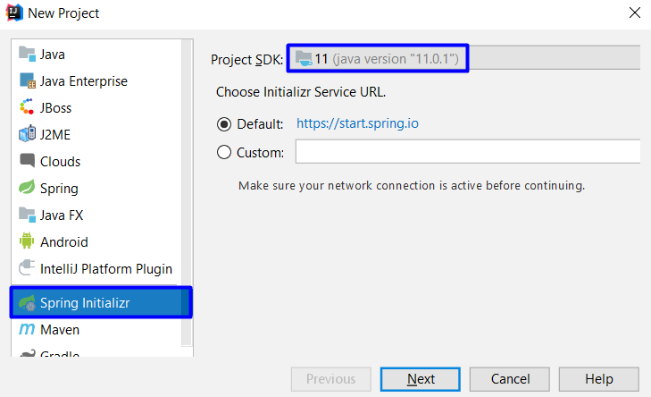

If your "**Project SDK**" field is empty, follow these steps:

Click on "**New**". From the drop-down choose **JDK**:

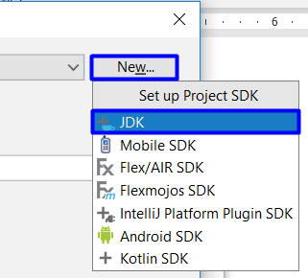

Then **locate your JDK**, it should be in the "**Program Files**" **folder** if you're using **windows**:

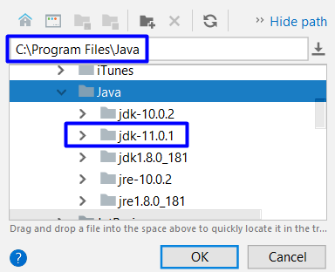

Your java should be set now, so we can continue by using the **values** from the **picture** **below**.

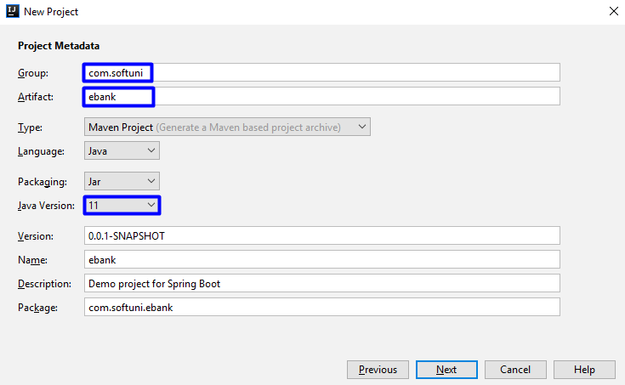

Now we will see **all of the things** that we **can** **include** in **our project**. We want to include only the following:

* From **Core** choose:
  + **DevTools**
* From **Web** choose:
* **Web**
* From **Template Engines** choose:
  + **Thymeleaf**
* From **Security** choose:
  + **Security**
* From **SQL** choose:
  + **MySQL**
  + **JPA**

You should have something like this:

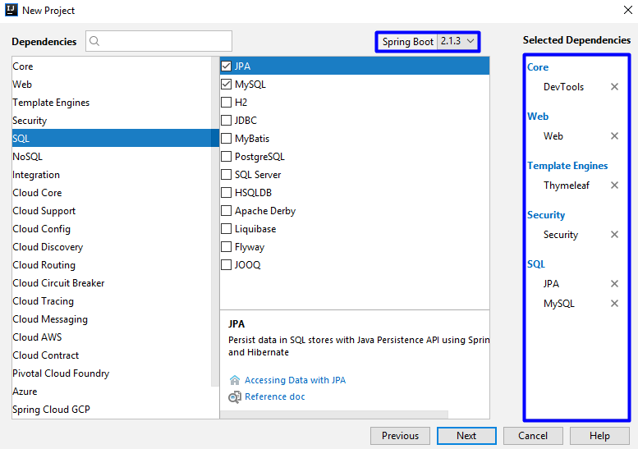

Click "**Next**" and on the final page click "**Finish**".

After a few seconds, you should have the project structure like this one:

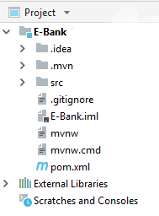

Ok, now we are going to open the file called "**pom.xml**". It contains **all of the modules** that **we've selected earlier using the Spring Initializr**, but they are not enough. In the file, search for this section:

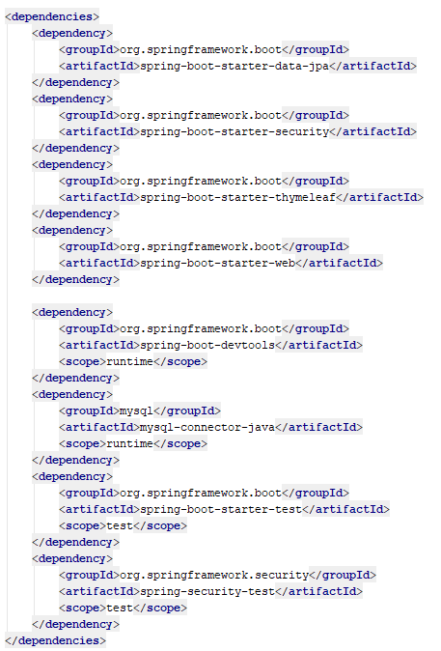

We want to **include** **additional dependency** that will help us later. If you see the **following window**:

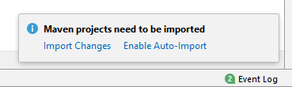

Click on "**Enable Auto-Import**". It is **really important** and if you miss this step, the **project might not work** as **you would expect**. Now that we've got this out of the way, we can import the **following dependency**:

|  |
| --- |
| <**dependency**>  <**groupId**>org.thymeleaf.extras</**groupId**>  <**artifactId**>thymeleaf-extras-springsecurity5</**artifactId**> </**dependency**> |

**Insert** this at the **bottom of the dependencies section,** orin other words:

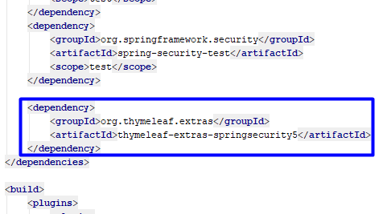

We need this for security, but more for that later.

The next thing we are going to do is create the DB connection. For database, we are going to use **MySQL**. That means that you will need to have **XAMPP**. Now you need to start the **MySQL module** in XAMPP and open **HeidiSQL**.

Now we need to create the connection with our project. Find the file "**application.properties**" in   
**"src/main/resources"** and paste this:

|  |
| --- |
| *# Database connection with the given database name* **spring.datasource.url** = **jdbc:mysql://localhost:3306/e_bank_db?createDatabaseIfNotExist=true&useSSL=false** *# Username and password* **spring.datasource.username** = **root spring.datasource.password** =  *# Hibernate ddl auto (create, create-drop, update): with "update" the database # schema will be automatically updated accordingly to java entities found in # the project # Using "create" will delete and recreate the tables every time the project is started* **spring.jpa.hibernate.ddl-auto** = **update spring.jpa.show-sql** = **true** *# Allows Hibernate to generate SQL optimized for a particular DBMS* **spring.jpa.properties.dialect** = **org.hibernate.dialect.MySQL5InnoDBDialect spring.jpa.properties.hibernate.format_sql**=**TRUE** *#Turn off Thymeleaf cache* **spring.thymeleaf.cache** = **false** |

Our connection is done. We will test it later.

Our **project is ready** now.

### Project Structure

Now, let’s take a look at our project structure.

There is only one folder we're interested at. That is the "**src**" folder. That folder will **contain all of the files** we are **going to create**. Let's take a look:

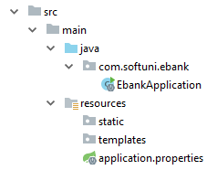

It contains main folder, which is then **separated into 2 different** folders. The first one is the "**java**" folder. This folder contains our **application package**. **Inside** that **package,** we are going to **create** our **entities**, **controllers**, **configurations**, etc. The other folder is called "**resources**". It contains one file that **creates the connection** with our **database**. There are two other folders named "**static**" and "**templates**". As you've probably have figured it out by now, the "**templates**" folder will contain the **templates** for our [templating engine](https://en.wikipedia.org/wiki/Template_processor). The "**static**" folder will contain the **stylesheets** and **javascripts** **we are going to use** in our project.

### Entities

At the moment, you **cannot use your project**. Why? Because we've **imported the dependency for Spring**, that gives us the **authentication module**, but we haven’t configured it, yet. To do that we will create User **entity** using Hibernate. Then we are going to tell **Spring Security** what to use from our entity. Finally, we will setup the **configuration** that will **allow us to login**. This **module** will **give us** the **user authorization** as well.

First, we will start with the Role entity. In **java/com/softuni/ebank** create new package called "entities"

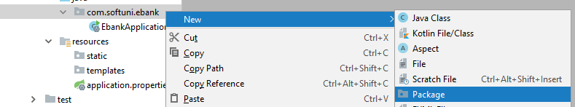

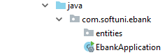

This package will contain all of our entities – **users**, **roles**, **bank accounts**, **transactions**.

#### Role Entity

We will start by **creating new Java** **class** called "Role":



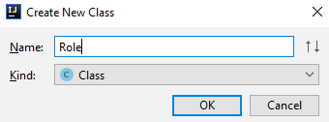

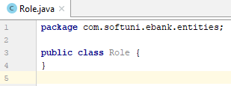

First we need to do is add **Entity** and **Table** annotations:

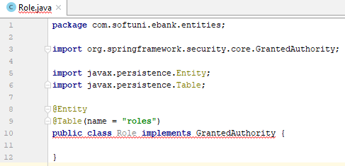

* **@Entity -** means that the Role class will become [entity](http://stackoverflow.com/questions/2550197/whats-the-difference-between-entity-and-class) that will get **saved into our database**.
* **@Table -** **defines the table name** in our **database.**

In class name "Role" click **"Alt"** + **"Enter"** and click **"Implement methods"**:

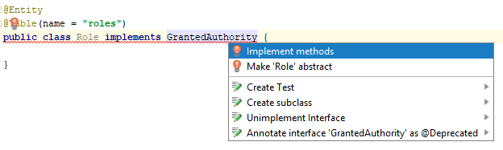

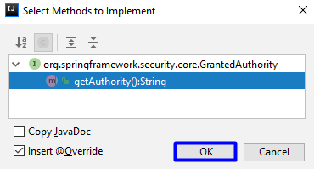

Create private fields "id" and "authority" and getters and setters (click **"Alt"** + **"Insert"**):

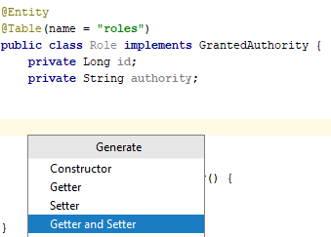

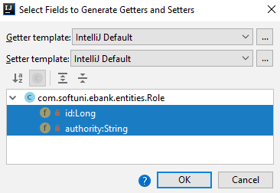

Only thing we need to do in this class is to create empty **constructor,** add annotations on "getId()" and **return** authority in "getAuthority()":

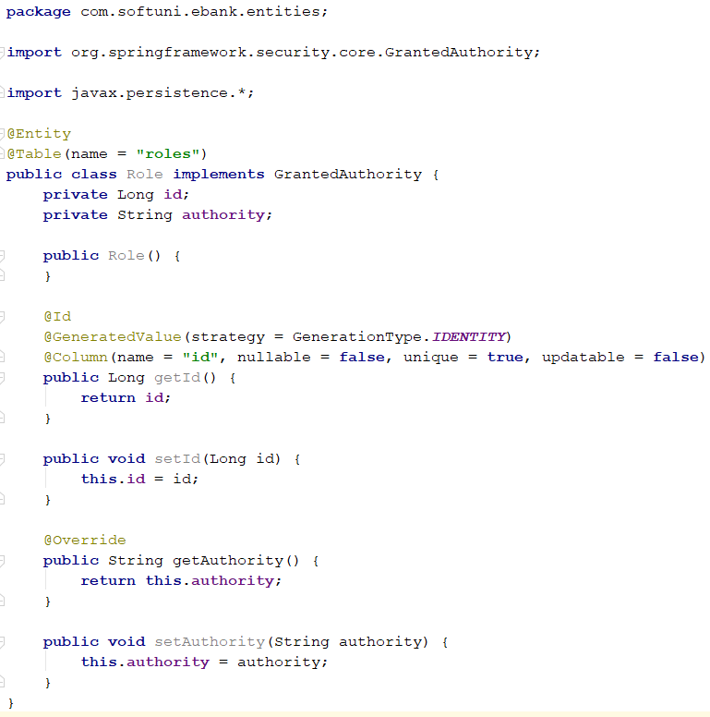

* **@Id -** tells [Hibernate](http://hibernate.org/orm/) that **this field will be the primary key** for our **database**. The second annotation make the **field generated automatically**, without us doing anything.
* **@Column –** **defines the column name** in our **table**.

#### User Entity

Next, we will create a User class in the "entites" package:

Write the following in it:

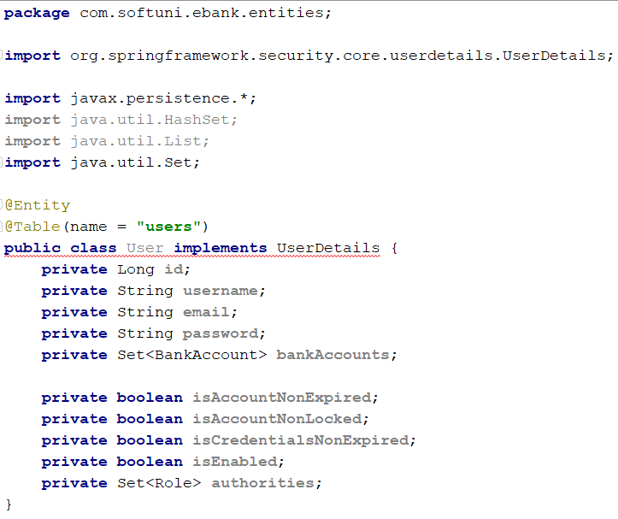

Create а default **controller** to initialize collections:

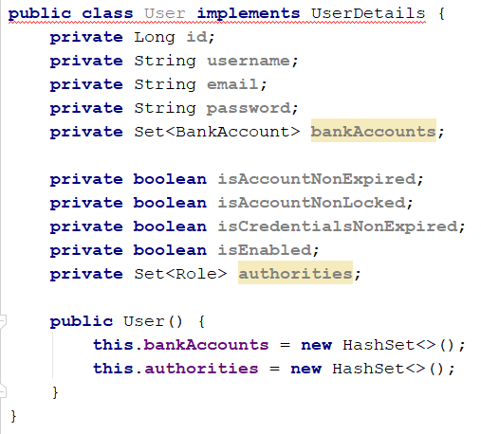

Create **getters** and **setters** for all **fields**. Then we will going through all **getters** to add **annotations**:

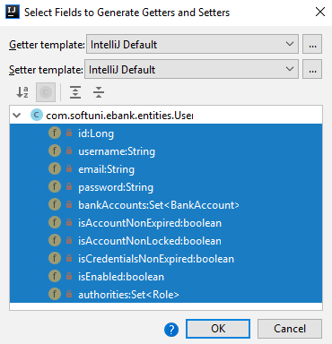

The annotations that we need to add is:

* "getId()":

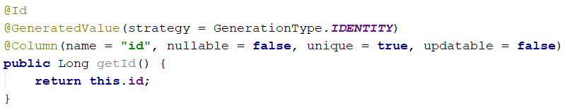

* "getUsername()":

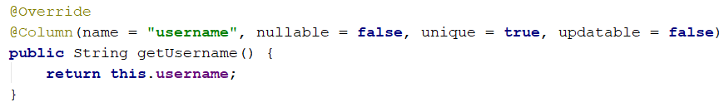

* "getEmail()":

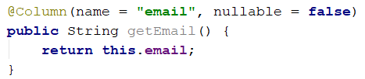

* "getPassword()":

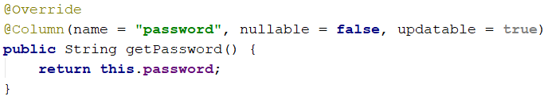

* "getBankAccounts()":

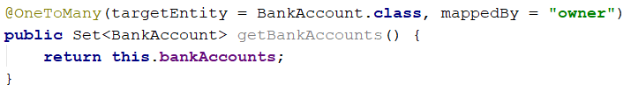

**@OneToMany -** represents [OneToMany](https://en.wikipedia.org/wiki/One-to-many_(data_model)) relationship from the side of the "one". Because we are working with the User entity, we are telling **Hibernate** that **one of our users** will correspond **to many bank accounts**.

* "isAccountNonExpired()":

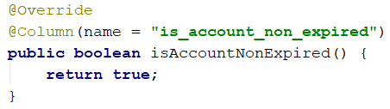

* "isAccountNonLocked()":

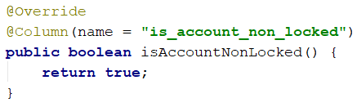

* "isCredentialsNonExpired()":

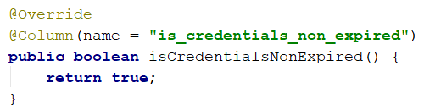

* "isEnabled()":

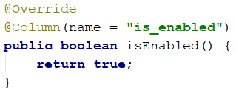

* "getAuthorities()":

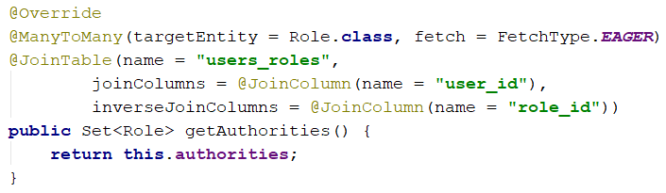

**@ManyToMany -** annotation we are telling that our "fetch" will be of type "EAGER". It basically means that we want the **roles to be loaded** **together** with the **user**. **Usually that will happen** when we want to **use the roles**, but that's an [advanced topic](https://howtoprogramwithjava.com/hibernate-eager-vs-lazy-fetch-type/). The other annotation will create the **joining table** for our relation and will **name it** "users_roles".

#### **BankAccount** Entity

Then, we need to create a BankAccount class in the "entites" package:

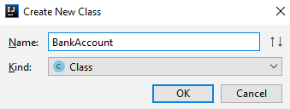

Write some code, so it look like this:

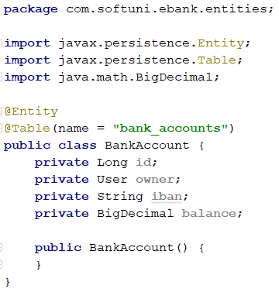

And again, create **getters** and **setters** and add **annotations** on **getters**:

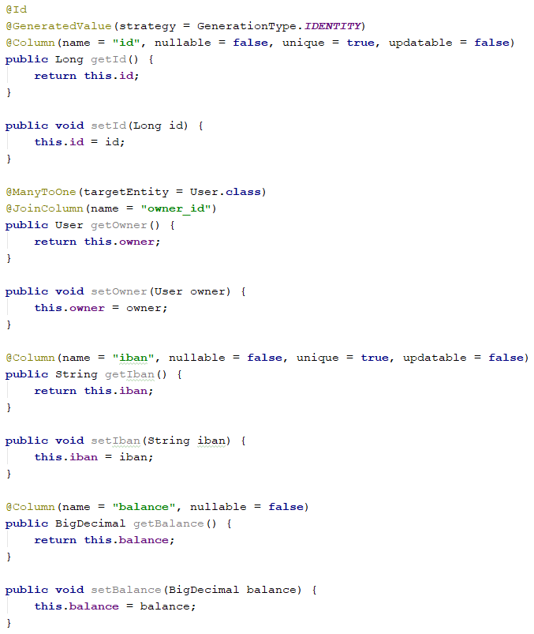

Ok. Those are our entities for now. Let’s see what we have next.

### Repositories

Our next step is to get our entities from the database. We will do this by creating some repositories.

In In **java/com/softuni/ebank** create new package called "repositories":

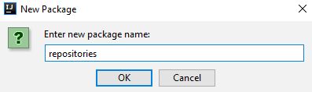

#### User Repository

In it create UserRepository, the important thing here is that it won’t be a class, it will be an [interface](http://tutorials.jenkov.com/java/interfaces.html). The interface is a special type, which **can't contain functional methods**. It can **only** **declare them**.

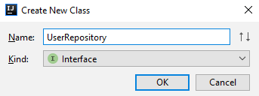

In it, write the following:

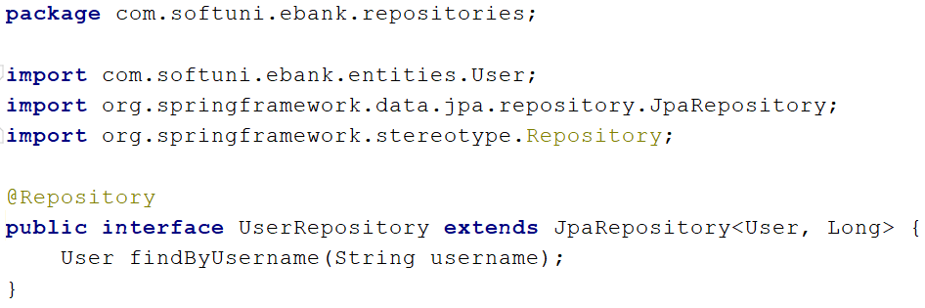

As you can see, this **method is different**. It doesn't have body. Using magic (and [reflection](http://www.javatpoint.com/java-reflection)) **Spring** will find a **user** **by** **his username**. It will use **reflection** to get the **type** of the **repository**, which is our entity "User", then it will get the **table** **name** from the **annotation**. After that, it will split the name of our method into different parts. The first part is "findBy", which means that it will send [SELECT](http://www.w3schools.com/sql/sql_select.asp) **query** to our **database**. Then it will take the **second part** which is "Username" in this case and it will understand that we want to get **user** by a **given** **username**. The **generated query** will look like this "SELECT id, username, email, password FROM users WHERE username={parameter}". Anyway, let's move on.

#### Role Repository

Ok, it is time to create the RoleRepository interface:

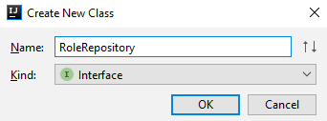

After that, write the following code in it:

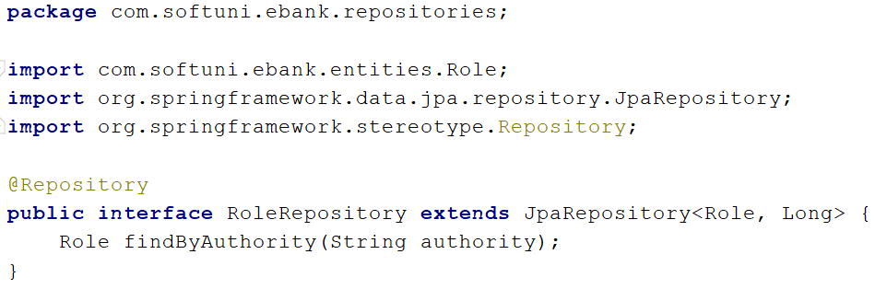

The method will get us the **role** with **given name**. It is almost the same as the method in the UserRepository, but the **criteria** and **return types** are **different**.

#### BankAccount Repository

Here comes the BankAccount repository.

In it, we write this.

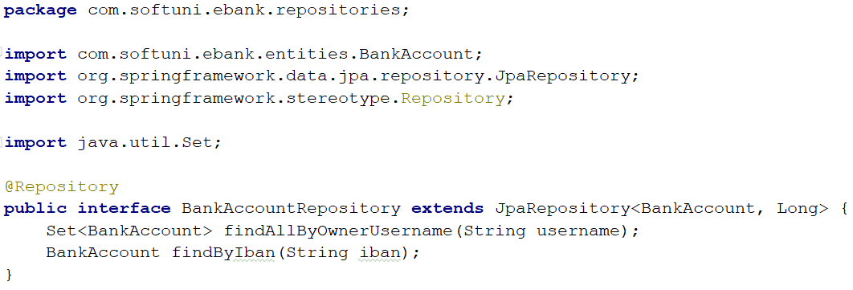

We are ready with our repositories for now.

### Services

We will use services in our app. Services are ordinary classes and their idea is to describe the business logic of the application.

Create a new package called "services" in **java/com/softuni/ebank**.

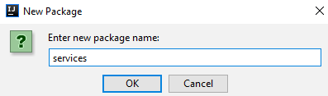

#### User Service

In the **services** package create class UserService with the following content:

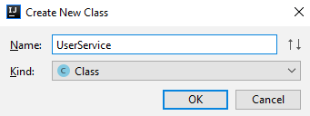

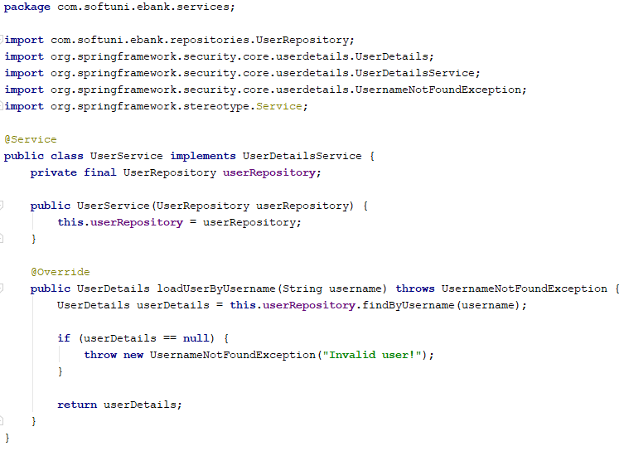

We will create the other services later.

### Configurations

We've got to the point, where we need to configure our **Security** module. We should start by creating a new "config" package in **java/com/softuni/ebank.**

In our **config** package we will create two classes.

#### ApplicationBeanConfiguration Class

The first one is called ApplicationBeanConfiguration**:**

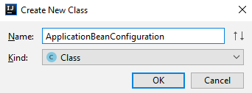

We will be using this class for configuring our BCryptPasswordEncoderused for encoding users’ passwords.

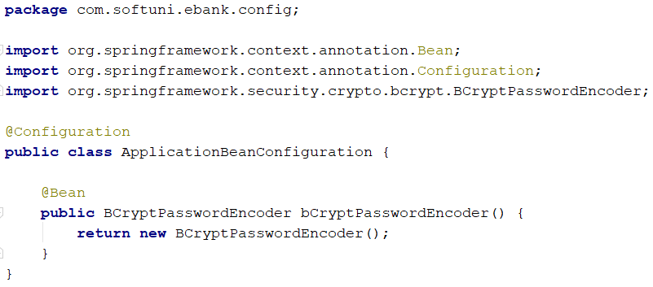

* **@Configuration -** indicates that a class declares one or more **@Bean** methods and may be processed by Spring, but more for that in the Java MVC Frameworks – Spring @ SoftUni.

#### ApplicationSecurityConfiguration Class

The second class that we must implement in the **config** package is ApplicationSecurityConfiguration:

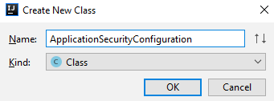

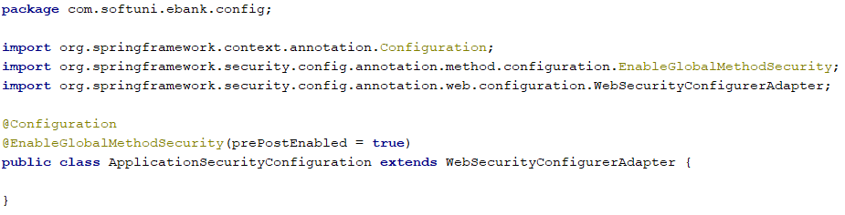

Here is the part, where things can get very messy. You must **be very careful** when you are creating your Security Configuration, check two or three times that you re-wrote the configuration correct. In our configuration class we will have two methods.

##### csrfTokenRepository()

The first one generates a token repository for our logged in user:

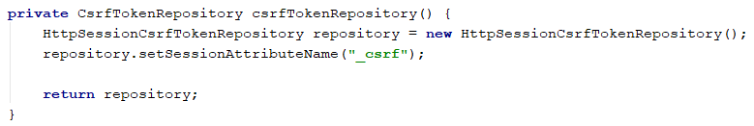

##### configure()

The second one is called **configure** and it is used to configure our permitted **urls** and login parameters:

|  |
| --- |
| @Override **protected void** configure(HttpSecurity http) **throws** Exception {  http  .cors()  .disable()  .csrf()  .csrfTokenRepository(**this**.csrfTokenRepository())  .and()  .authorizeRequests()  .antMatchers(**"/"**, **"/register"**, **"/login"**).permitAll()  .antMatchers(**"/css/**"**, **"/js/**"**).permitAll()  .anyRequest().authenticated()  .and()  .formLogin()  .loginPage(**"/login"**)  .usernameParameter(**"username"**)  .passwordParameter(**"password"**)  .defaultSuccessUrl(**"/home"**)  ; } |

We are ready with our security.

### Views

The next thing we have to do is create our views, but first let’s take a look at our resources **folder**.

We have **static resources** like **stylesheets** and **scripts** (those will be given to you) and just copy paste the files in given packages like the picture below.

Note if your css package is like this:

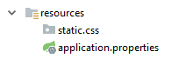

Just disable **"Compact Middle Packages":**

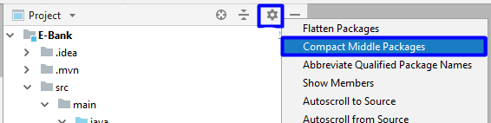

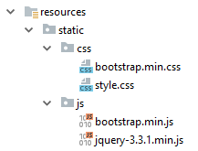

We have a **templates** folder. Our views stay in templates folder.

Copy-paste views from given resources folder to templates folder:

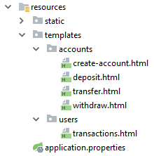

Every time we want to create a view, the html code will be given. For now we have to create the following things.

#### head Html File

In **fragments** folder(you will have to create it in **resources/templates**) create new **html file** called **head**:

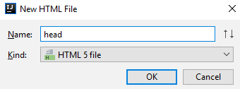

**Delete** everything from it and **paste** the following html code.

|  |
| --- |
| <**th:block th:fragment**>  <**meta charset="UTF-8"**>  <**meta name="viewport" content="width=device-width, initial-scale=1.0"**>  <**title**>E-Bank</**title**>  <**link rel="stylesheet" th:href="@{/css/bootstrap.min.css}"**>  <**link rel="stylesheet" th:href="@{/css/style.css}"**>  <**script src="/js/jquery-3.3.1.min.js"**></**script**>  <**script src="/js/bootstrap.min.js"**></**script**> </**th:block**> |

#### footer Html File

Next fragment we are going to create is called **footer**(it stays at the bottom of our pages).

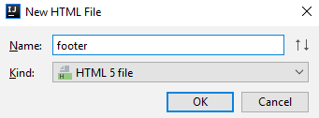

Again **delete** everything and paste this:

|  |
| --- |
| <**th:block th:fragment**>  <**footer class="footer py-3 fixed-bottom"**>  <**div class="container-fluid"**>  <**div class="container-fluid text-center"**>© CopyRight Abazov Web Design Studios 2019. All rights reserved.  </**div**>  </**div**>  </**footer**> </**th:block**> |

#### navbar Html File

The third fragment in our **resources/templates/fragments** will be the **navbar** fragment.

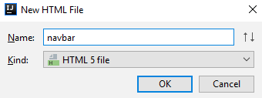

Again we **delete** everything from it and **paste**:

|  |
| --- |
| <**th:block th:fragment**>  <**nav class="navbar navbar-expand-lg navbar-dark bg-color-dark"**>  <**a class="navbar-brand h4" th:href="@{/}"**>E-Bank™</**a**>  <**button class="navbar-toggler navbar-toggler-right" type="button" data-toggle="collapse"  data-target="#navbarSupportedContent" aria-controls="navbarSupportedContent" aria-expanded="false"  aria-label="Toggle navigation"**>  <**span class="navbar-toggler-icon"**></**span**>  </**button**>  <**div class="collapse navbar-collapse justify-content-end row" id="navbarSupportedContent"**>  <**ul class="navbar-nav ml-auto"**>  <**li class="nav-item active col-md-4"**>  <**a class="nav-link h5" th:href="@{/home}"**>Home</**a**>  </**li**>  <**th:block sec:authorize="isAnonymous()"**>  <**li class="nav-item active col-md-4"**>  <**a class="nav-link h5" th:href="@{/login}"**>Login</**a**>  </**li**>  <**li class="nav-item active col-md-4"**>  <**a class="nav-link h5" th:href="@{/register}"**>Register</**a**>  </**li**>  </**th:block**>  <**th:block sec:authorize="isAuthenticated()"**>  <**li class="nav-item active col-md-4"**>  <**a class="nav-link h5" th:href="@{/transactions}"**>Transactions</**a**>  </**li**>  <**li class="nav-item active col-md-4"**>  <**form th:action="@{/logout}" th:method="post"**>  <**button class="nav-link h5 border-0 text-white bg-transparent" th:href="@{/logout}"**>Logout  </**button**>  </**form**>  </**li**>  </**th:block**>  </**ul**>  </**div**>  </**nav**> </**th:block**> |

What buttons will be shown in the navbar depends on that are we **logged in** or **not**. That’s come from **Thymeleaf Security** dependency we added earlier.

#### layout Html File

Our final fragment will be the **layout fragment.**

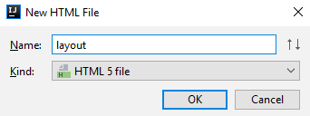

You guessed right. We **delete** everything and **paste:**

|  |
| --- |
| <!DOCTYPE **html**> <**html lang="en" xmlns:th="http://www.thymeleaf.org" xmlns:sec="http://www.thymeleaf.org/extras/spring-security"**> <**head**>  <**th:block th:include="~{fragments/head}"**></**th:block**> </**head**> <**body**> <**header**>  <**th:block th:include="~{fragments/navbar}"**></**th:block**> </**header**> <**main class="bg"**>  <**div class="jumbotron col-md-11 mx-5"**>  <**th:block th:include="${view}"**></**th:block**>  </**div**> </**main**> <**footer**>  <**th:block th:include="~{fragments/footer}"**></**th:block**> </**footer**> </**body**> </**html**> |

In our layout we have our **head**, **navbar** and **footer** included via **Thymeleaf** and every time we want to open a given page, **Thymeleaf** will include only the needed view, so we won’t be needing to insert the head, the navbar and the footer.

### Home Page

Now we will need some **index** and **home** views.

#### Index View

Inside **resources/templates** create new html file named **index.**

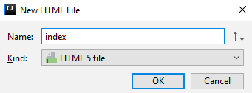

And **paste** this after you **delete** the given text

|  |
| --- |
| <**th:block**>  <**h1 class="text-center"**>Welcome to E-Bank</**h1**>  <**p class="text-center"**>Online Banking System</**p**>  <**hr**/>  <**p sec:authorize="isAnonymous()" class="text-center"**>If you have an account <**a th:href="@{/login}"**>Login</**a**>, if you  don't - <**a th:href="@{/register}"**>Register</**a**></**p**> </**th:block**> |

#### home View

Again inside **resources/templates** create another html file named **home** and inside of it **paste**:

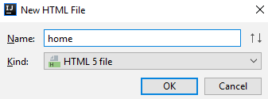

|  |
| --- |
| <**th:block**>  <**h1 class="text-center" th:text="|Hello, ${username}|"**></**h1**>  <**p class="text-center"**>Your bank accounts are listed below.</**p**>  <**hr**/>  <**p class="text-center"**>If you want to create an account, click <**a th:href="@{/accounts/create}"**>Here</**a**></**p**>  <**div class="d-flex justify-content-center align-items-center container"**>  <**table class="table table-striped"**>  <**thead**>  <**tr**>  <**th scope="col"**>#</**th**>  <**th scope="col"**>IBan</**th**>  <**th scope="col"**>Balance</**th**>  <**th scope="col"**>Actions</**th**>  </**tr**>  </**thead**>  <**tbody**>  <**th:block th:each="account, iter : ${accounts}"**>  <**tr**>  <**td scope="row" th:text="${iter.index + 1}"**></**td**>  <**td scope="row" th:text="${account.iban}"**></**td**>  <**td scope="row" th:text="${account.balance}"**></**td**>  <**td scope="row"**>  <**a th:href="@{/accounts/deposit/{id}(id=${account.id})}" class="btn btn-success"**>Deposit</**a**>  <**a th:href="@{/accounts/withdraw/{id}(id=${account.id})}" class="btn btn-danger"**>Withdraw</**a**>  <**a th:href="@{/accounts/transfer/{id}(id=${account.id})}" class="btn btn-info"**>Transfer</**a**>  </**td**>  </**tr**>  </**th:block**>  </**tbody**>  </**table**>  </**div**>  </**th:block**> |

Next step is to create a package **controllers** inside **java/com/softuni/ebank.**

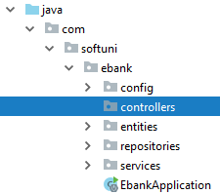

### Create HomeController Class

The first controller we are going to create is HomeController and it stays in the   
newly created "**controllers**" package.

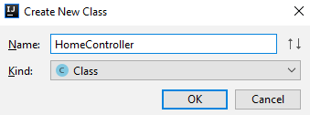

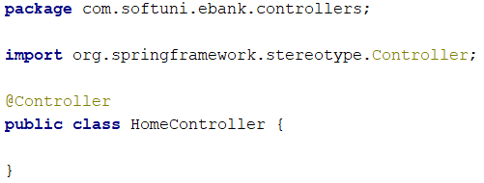

### Create BankAccountService Class

Before creating home() method in HomeController we need to create BankAccountService   
in "**services"** package:

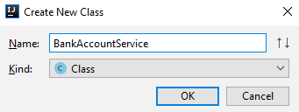

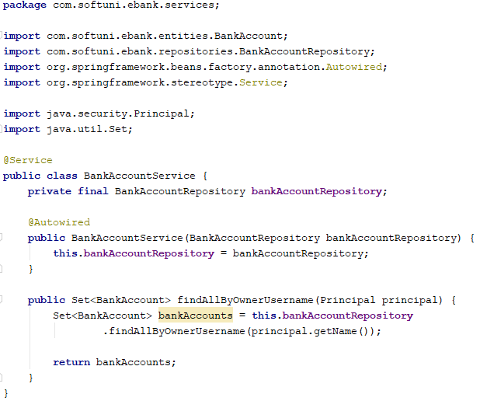

* We create constant field bankAccountRepository and we set the value from the constructor. Spring knows what to pass to the constructor by so-called [dependency injection](https://en.wikipedia.org/wiki/Dependency_injection) technique.
* With findAllByOwnerUsername method we get all bank accounts of the current user from the database.

Now our HomeController must look like this:

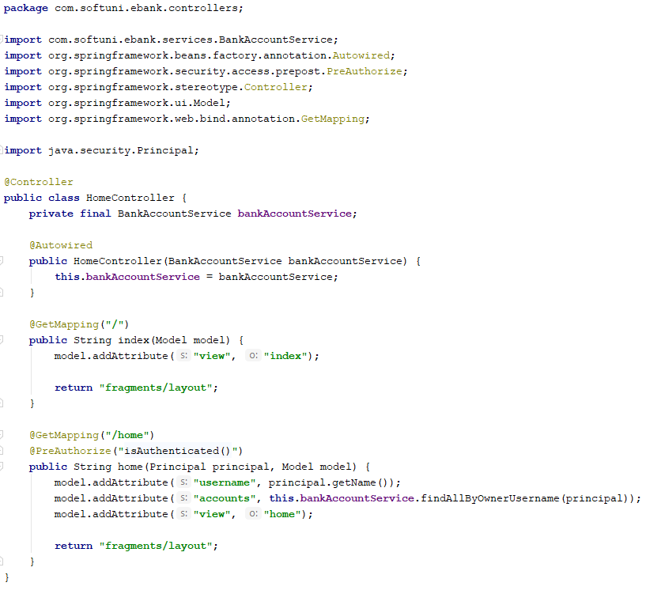

* @PreAuthorize("isAuthenticated()") **–** this means that the **home** action can be accessed only when we have **logged in** user.

Now if we run the application (and you have done everything described above correctly)   
we should be able to see our index page.

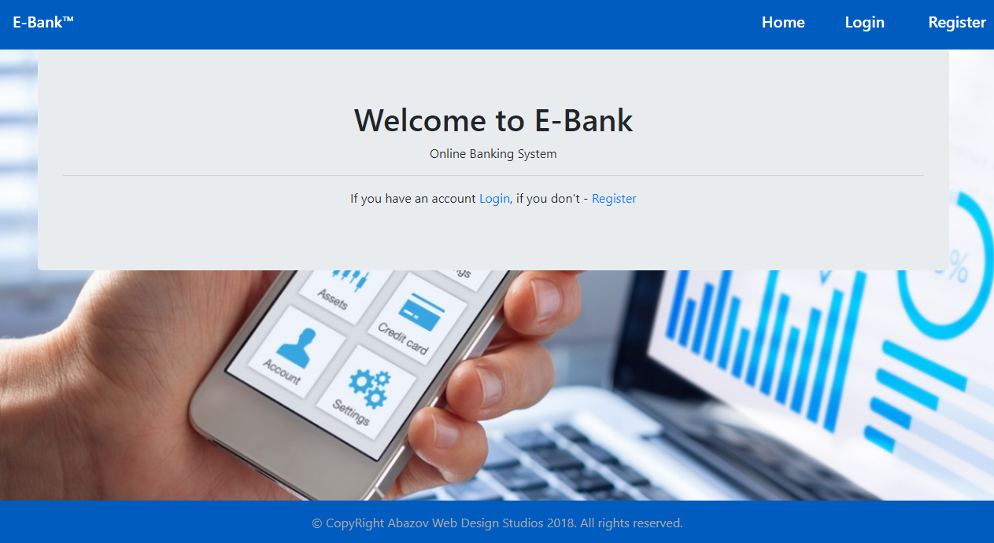

If you've downloaded the **skeleton**, this is your **starting point**. After importing it and run the application you should see the index page. So we have our index page and spring create a database for us but we have no functionality.

## User Registration and Login

If we click on register or login, nothing happens. That’s because we don’t have views and controllers to register and login.

Great, first we create some views.

Inside **resources/templates/users** we will put our views, that are related to the user.

### Create Views

#### register-user View

First, we create the **register** view.

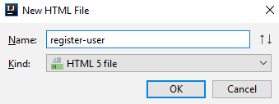

Like before, we **delete** everything and we **put** this in it.

|  |
| --- |
| <**th:block**>  <**div class="text-center"**>  <**h1**>Register</**h1**>  <**hr**/>  <**div class="d-flex justify-content-center align-items-center container "**>  <**form class="col-md-4" th:action="@{/register}" th:method="post" th:object="${userBindingModel}"**>  <**div class="form-group"**>  <**label for="username"**>Username</**label**>  <**input type="text" class="form-control" id="username" placeholder="Enter username"  th:field="*{username}" required**>  </**div**>  <**div class="form-group"**>  <**label for="email"**>Email address</**label**>  <**input type="email" class="form-control" id="email" aria-describedby="emailHelp"  placeholder="Enter email" th:field="*{email}" required**>  </**div**>  <**div class="form-group"**>  <**label for="password"**>Password</**label**>  <**input type="password" class="form-control" id="password" placeholder="Password"  th:field="*{password}" required**>  </**div**>  <**div class="form-group"**>  <**label for="password"**>Confirm Password</**label**>  <**input type="password" class="form-control" id="confirmPassword" placeholder="Confirm Password"  th:field="*{confirmPassword}" required**>  </**div**>  <**button type="submit" class="btn btn-primary"**>Register</**button**>  </**form**>  </**div**>  </**div**> </**th:block**> |

#### login-user View

Next, it is time for the **login** view.

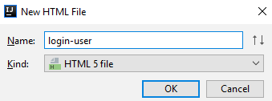

This should be pasted in this view.

|  |
| --- |
| <**th:block**>  <**div class="text-center"**>  <**h1**>Login</**h1**>  <**hr**/>  <**div class="d-flex justify-content-center align-items-center container "**>  <**form class="col-md-4" th:action="@{/login}" th:method="post" th:object="${userBindingModel}"**>  <**div class="form-group"**>  <**label for="username"**>Username</**label**>  <**input type="text" class="form-control" id="username" placeholder="Enter username"  th:field="*{username}" required**>  </**div**>  <**div class="form-group"**>  <**label for="password"**>Password</**label**>  <**input type="password" class="form-control" id="password" placeholder="Password"  th:field="*{password}" required**>  </**div**>  <**input type="hidden" th:name="${_csrf.parameterName}" th:value="${_csrf.token}"**>  <**button type="submit" class="btn btn-primary"**>Login</**button**>  </**form**>  </**div**>  </**div**> </**th:block**> |

### Binding Models

Enough for the views, next thing we have to do is the so-called **BindingModel.**

Binding models allows to map HTTP requested data with a model. In other words we will use binding models to send our data to a particular view and receive data in the form view.

Inside **java/com/softuni/ebank** create new package "**bindingModels**".

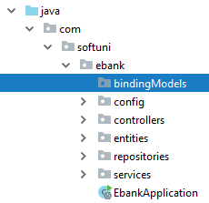

#### Create UserBindingModel Class

In the "**bindingModels**" package, we must create a new class called UserBindingModel.

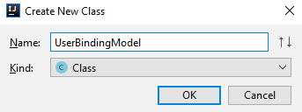

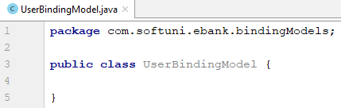

Create private fields and getters and setters (click **"Alt"** + **"Insert"**):

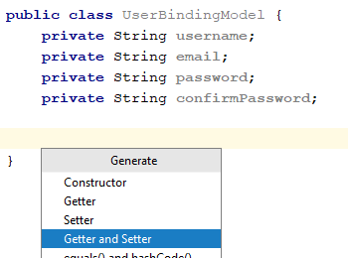

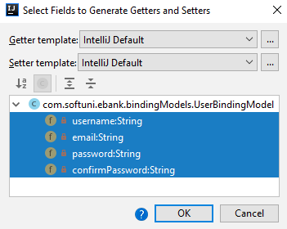

The only thing we need to do in this class is to create empty **constructor** and add annotations "@NotNull" and "@NotEmpty" to all get **methods**:

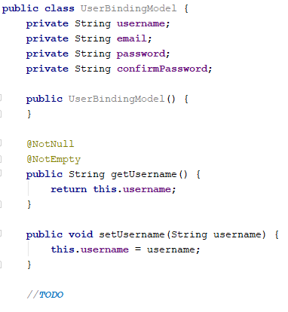

### Create RoleService Class

In RoleService class we create "seedRolesInDb()" method. This method is used for **seeding roles** in database, whenever we register our first user.

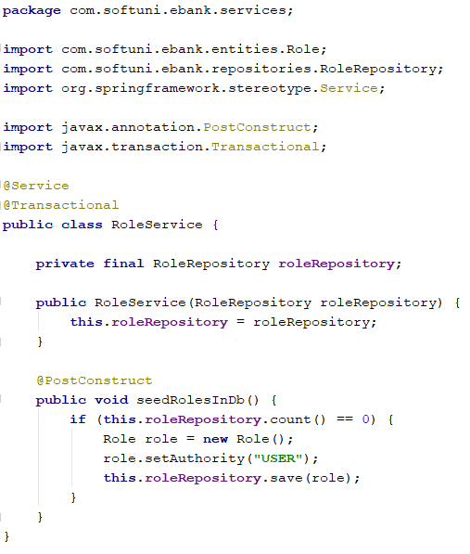

* With annotation @PostConstruct method seedRolesInDb() will be used without us calling it and it will be used only when we start the application

### Add Method in UserService Class

In UserService, we create a method to check if we already have a **user** with that **username**. And if we do not, we'll add the new user to the database. But before that, we must create constant fields for BcryptPasswordEncoder and RoleRepository and set values to them through the constructor:

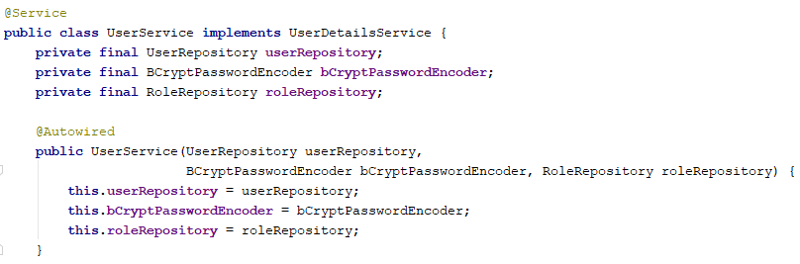

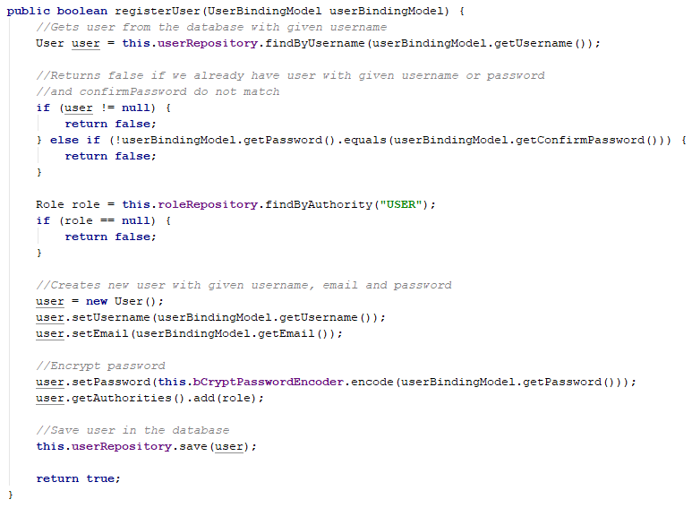

### Create UserController Class

Great, now it is time to create a UserController class inside our "**controllers**" package.

Let’s start implementing the user controller. The first thing is to create **fields** and **constructor**.

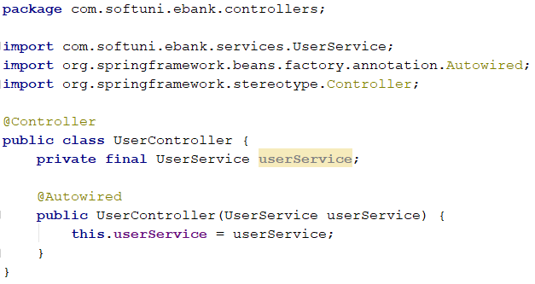

We are using the "**@Autowired**" annotation, to tell **Spring** to **initialize those fields**.

First, we need to be able to create users. Create the following method:

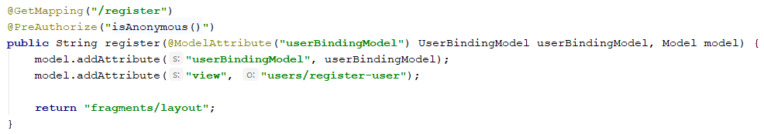

We are using the "@GetMapping" annotation. This annotation defines that the type of the [request](http://www.w3schools.com/TAGS/ref_httpmethods.asp) we are going to **process in our method** is "**GET**". That means that if **someone sends data** (i.e. user data), this method won't be called. **This** **method** will **only be called** if someone **tries to open the page** that is **hidden** **behind** the **route**. The model **parameter** will be used to **send data to our view**. With "fragments/layout" we **return the view**.

@PreAuthorize("isAnonymous()") **–** this means that the **register** action can be accessed only when we have **anonymous** user.

Create a new method called "registerConfirm". This method will have the hard job to **create a new user**. **Spring** will automatically map the form data to our binding model. The only thing that we need to do is **define routing**:

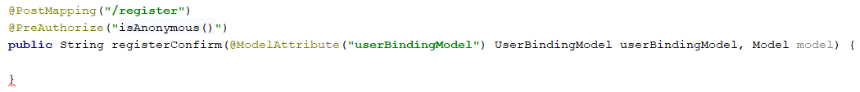

The PostMapping annotation corresponds to the form method. It means that we will **receive data** from somewhere. The first we want to do in our method is to **check if already have user with that username**. If we have we will **ignore the form submission**:

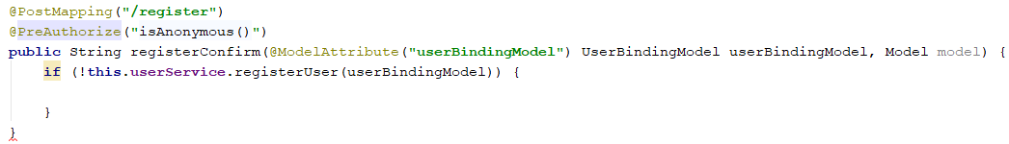

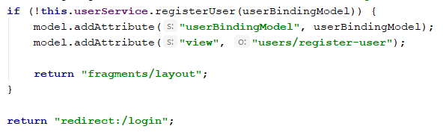

To create a login, we need **only "GET" method**. **Spring Security** **will take care of the rest**. Let's start with the method in our UserController:

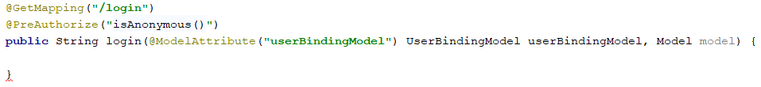

This method will need to **return the login view** and nothing else:

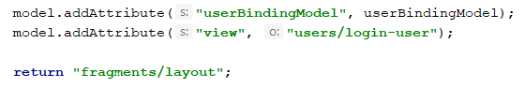

We are done with our **register** and **login** actions and if we worked correctly, when we start our application, register user and login, we should see this.

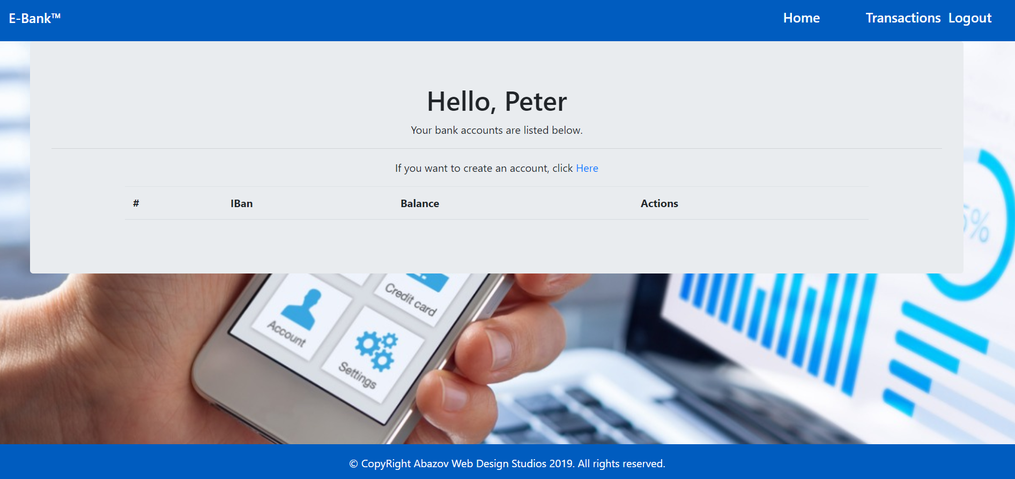

## Bank Accounts

Ok, so far, so good. Now we have to implement the logic about creating a bank account.

### Create **BankAccountBindingModel Class**

Next thing we do, inside the "**bindingModels**" package create BankAccountBindingModel**.**

In BankAccountBindingModel we will have field and empty constructor:

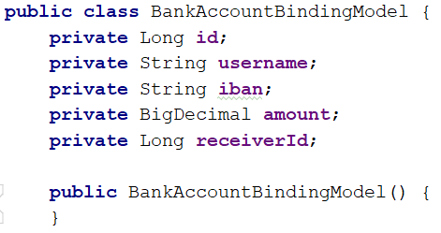

We also have to create getters and setters (click **"Alt"** + **"Insert"**), add annotations **"@NotNull"** and **"@NotEmpty"** to all of the **get** **methods** like in UserBindingModel:

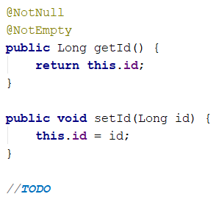

### Create Method in BankAccountService Class

First add UserRepository field:

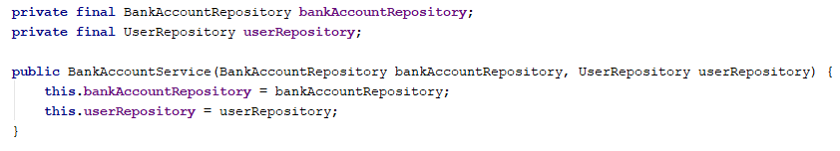

Inside the BankAccountService class we create method "createAccount":

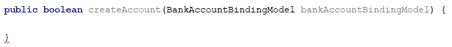

In the method first checks if the **IBAN** from the **binding model** is **null** or **empty** and **return false**:



If already have bank account with binding model's IBAN return false, because IBAN must be unique:

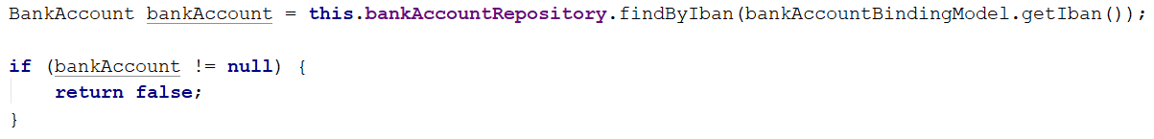

Then get the **user** from the **database** with **binding model's username** and again return false   
if we don’t have such user:

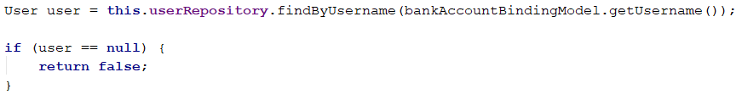

Finally if we have valid IBAN and user, we create a bank account and sets his user, IBAN and initial balance. At the end, save the bank account in the database and return true that means we successfully created bank account:

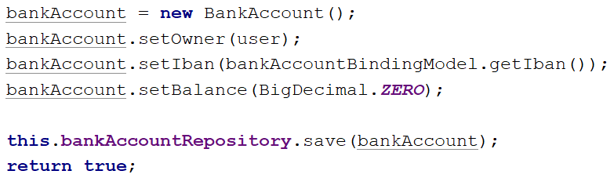

### Create BankAccountController Class

Let’s implement our controller now.

Inside the "**controllers**" package we create BankAccountController class

Again, we have to create **fields** and **constructor**:

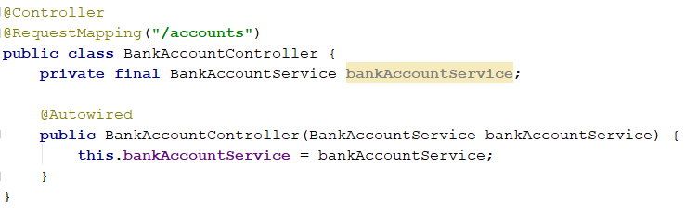

* @RequestMapping("/accounts") - The class-level annotation maps a specific request path on to a controller. You can then apply additional method-level annotations to make mappings more specific to handler methods.

Now we will implement our logic for creating a bank account.

Again we have **two methods**. **Get** method and **Post** method.

We start with the **Get** method:

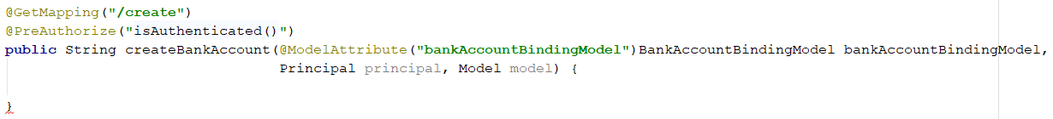

* @PreAuthorize("isAuthenticated()") **–** this means that the **/accounts/create** action can be accessed only when we have **logged in** user.
* Here when click on this action the path will be "http://localhost:8080**/accounts/create**"

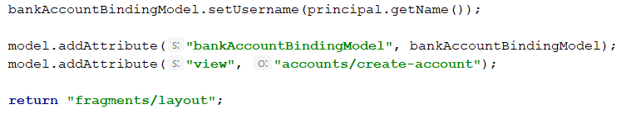

Now, the **post** method:

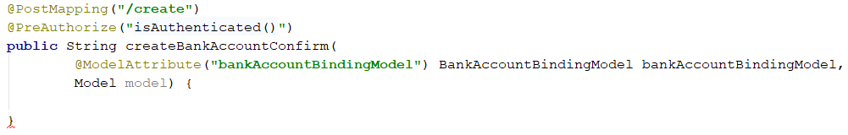

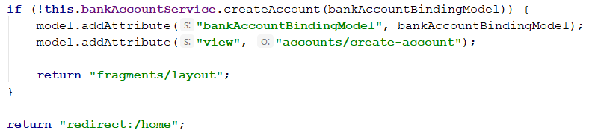

The logic here is if successfully create bank account, return **home** page, otherwise again return create-account view with the invalid data.

That’s all for creating an account. If you worked correctly your home page should look like this after creating an account.

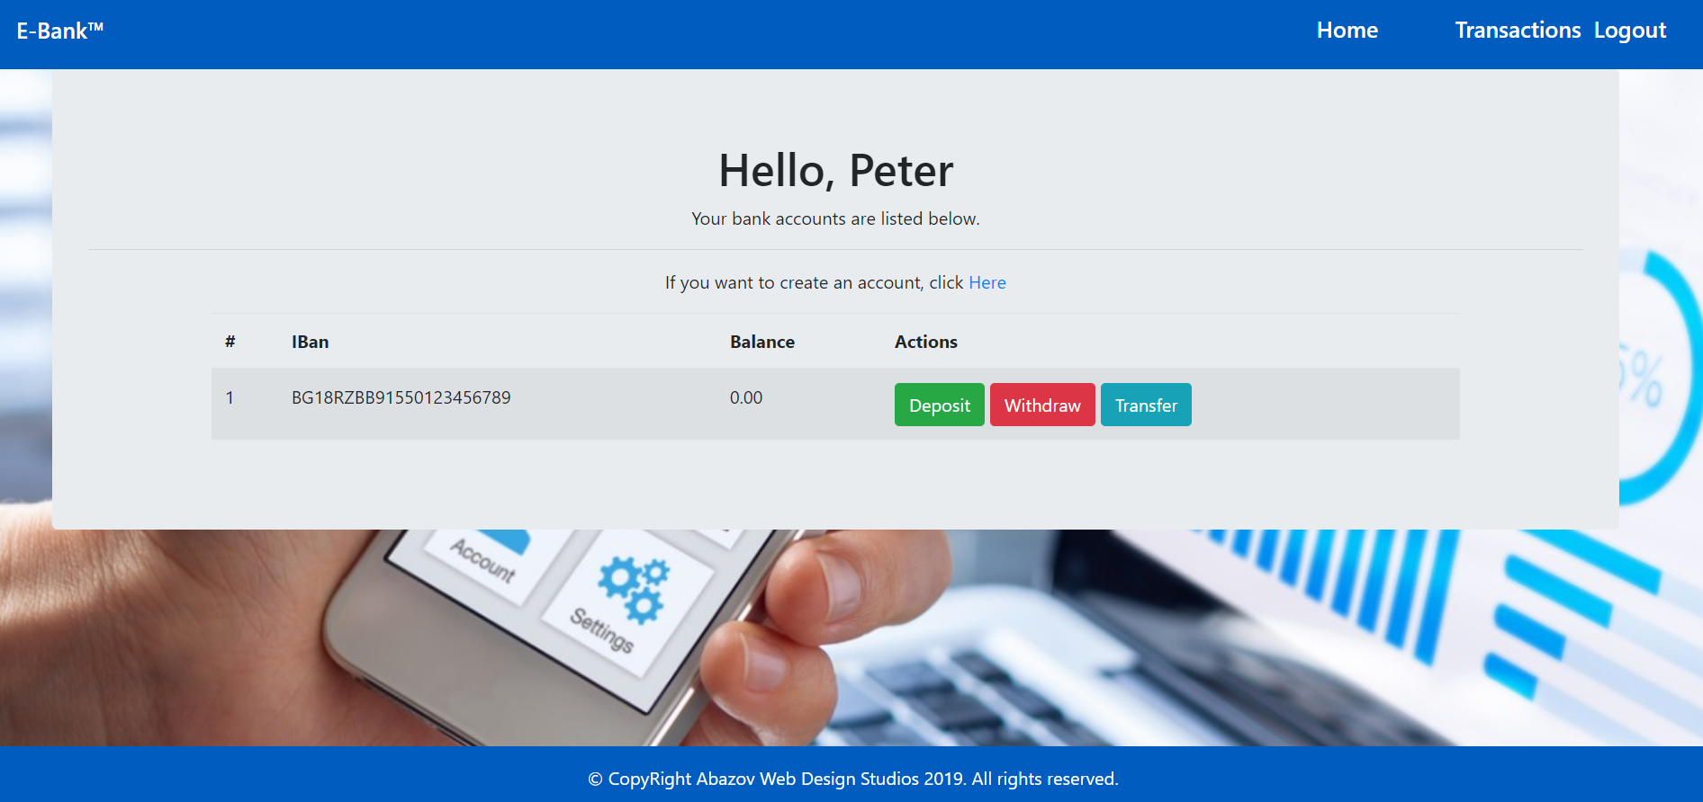

## Create Transaction Entity

Our next move will be creating a Transaction entity in the entities package.

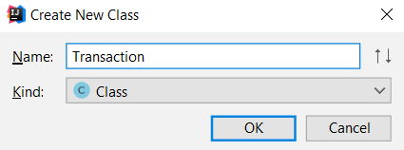

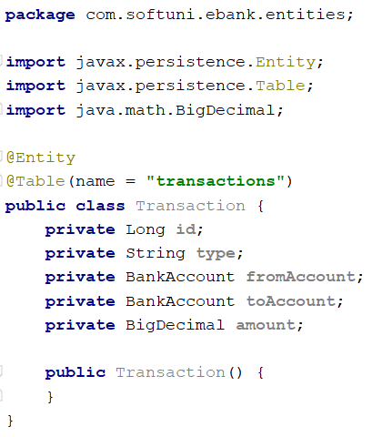

Create Getters and Setters and add Annotations on getters:

* **getId()**

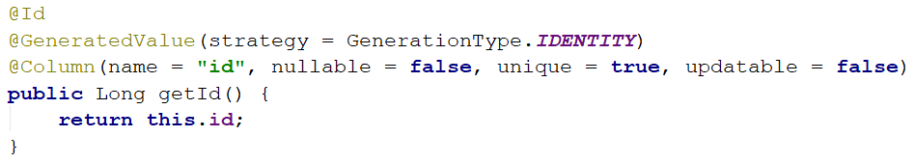

* **getType()**

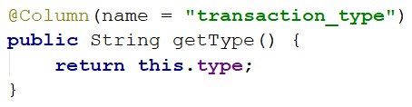

* **getFromAccount()**

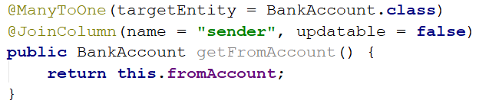

* **getToAccount()**

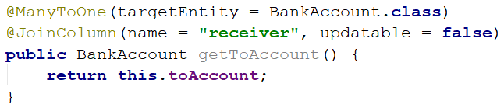

* **getAmount()**

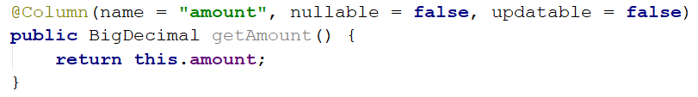

## Create TransactionRepository Class

Next we need a repository for our transactions.

Inside "**repositories**" package, we create new interface TransactionRepository:

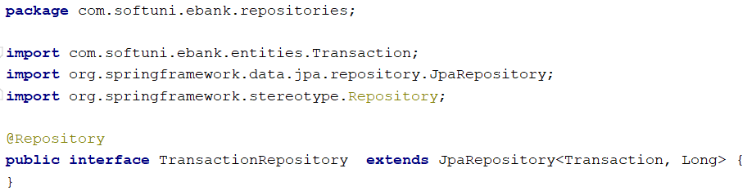

## Deposit

It is time to create **deposit** actions.

### Create Methods in BankAccountService

First add TransactionRepository field:

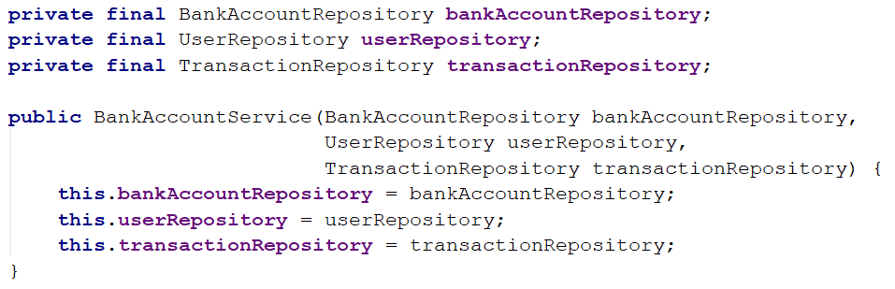

The first method is "extractAccountForTransaction(id)":

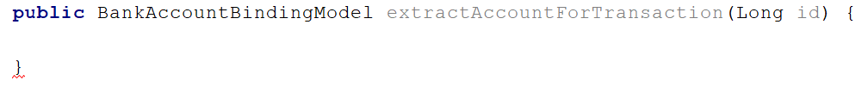

In this method we get bank account from the database with a given id and check if this bankAccount is null. If this condition returns true, throw exception, otherwise create BankAccountBindingModel variable and set id, owners username, and IBAN. This is all of the data that we needed in this view:

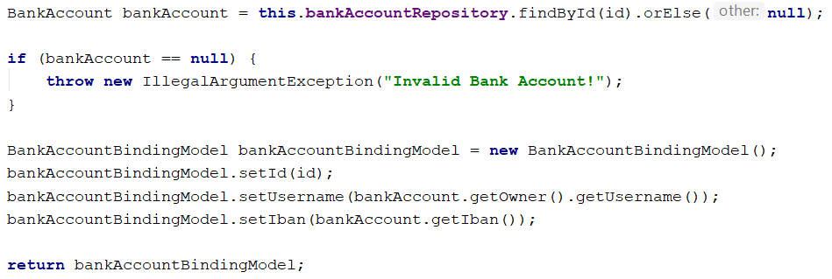

The second one is "depositAmount(bankAccountBindingModel)":



And again create validations then update bank account balance:

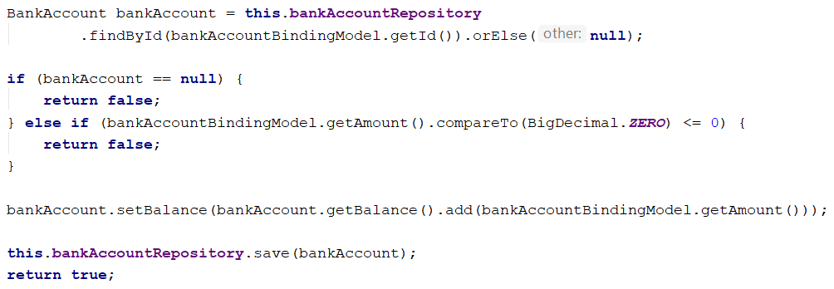

When we make a deposit from one account to another actually this is transaction. Therefore create а new Transaction and set its data:

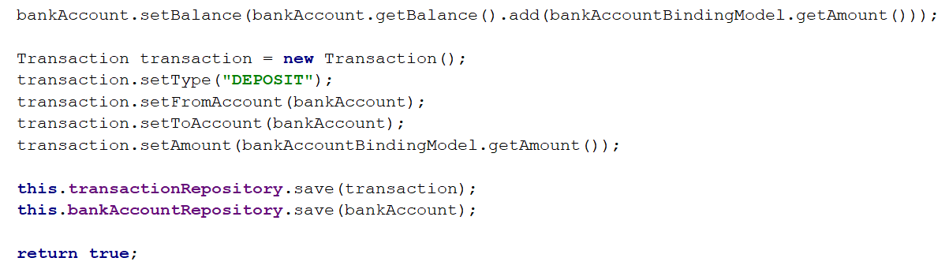

### **Create Deposit Actions in BankAccountController**

Great. Now let’s head to the BankAccountController and implement **get** and **post** methods for **deposit**.

This is the **Get** method:

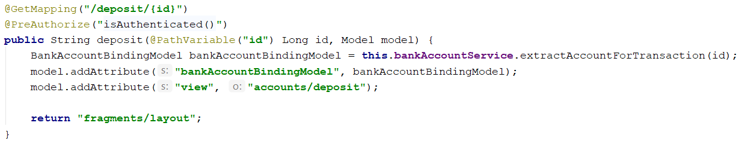

And here is the **Post** method:

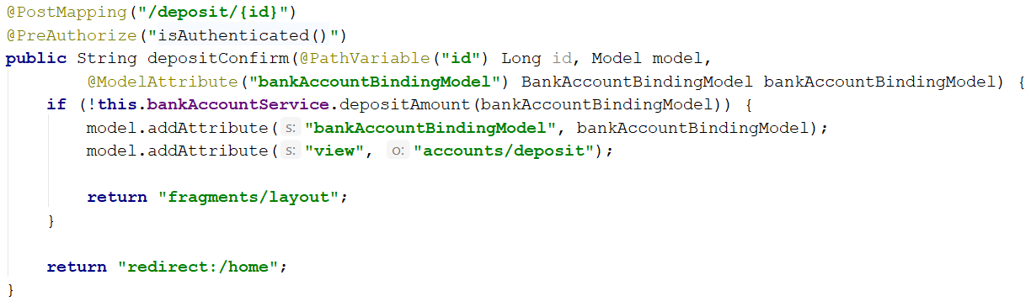

Ok, that’s all for depositing amount into bank account.

## Withdraw

It is up to you to implement the **withdraw** action. It is pretty much the same.

### Create Methods in BankAccountService

The method that is almost the same as "**depositAmount(bankAccountBindingModel)**":

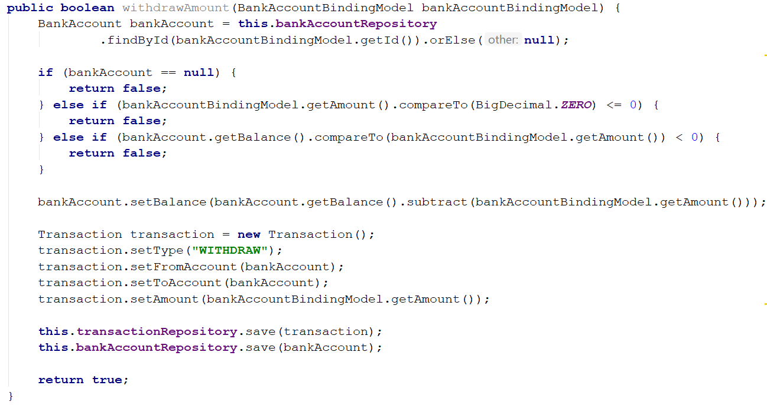

### **Create Withdraw Actions in BankAccountController**

Again, you must have a **Get** method and **Post** method:

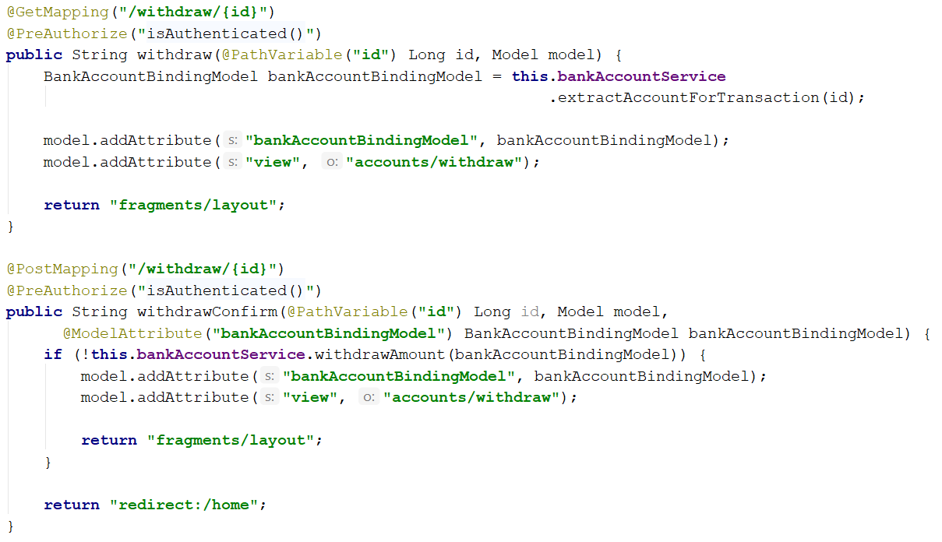

## Transfer

### Create Method in BankAccountService

Create method "transferAmount()" that transfers amount from one bank account to another.   
The method will look like:

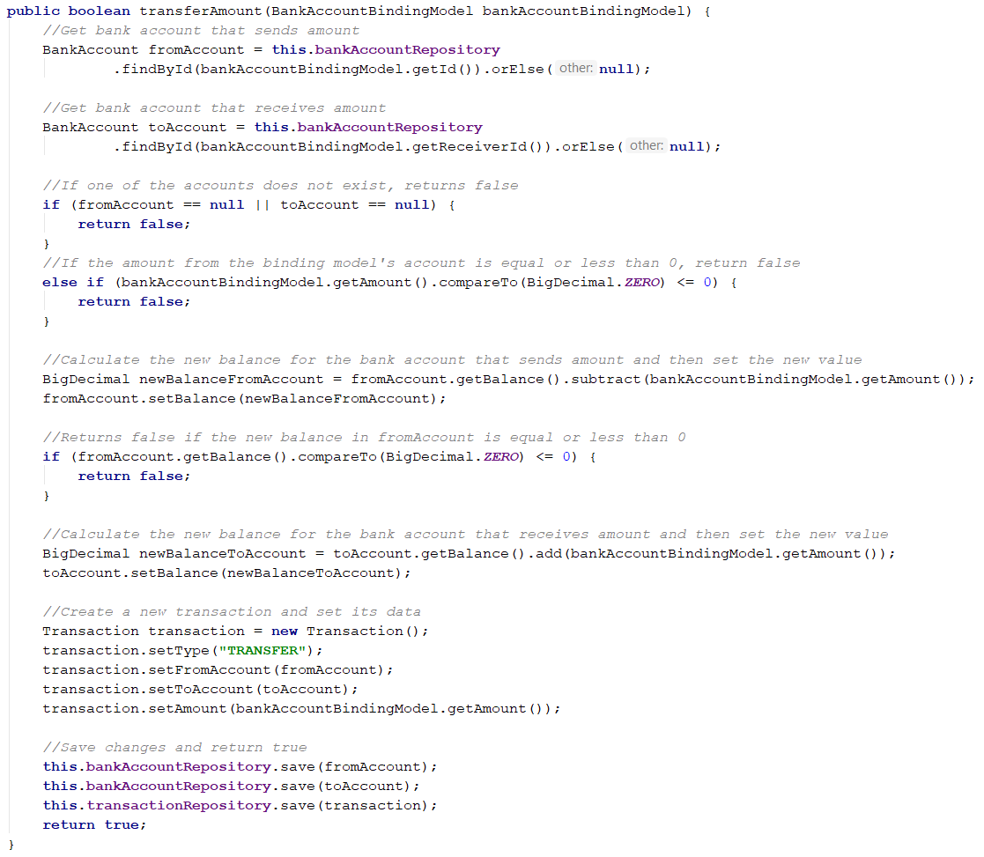

In the GET action, we want to visualize all bank accounts and choose toward which one to make the transfer. To do that we will create another method in BankService with the flowing functionality:

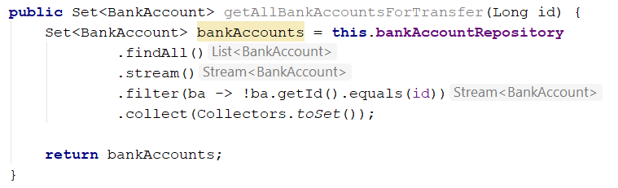

### Create Transfer Actions in BankAccountController

It is up to you to implement the **transfer** action. It is pretty much the same.

This is the **get** method:

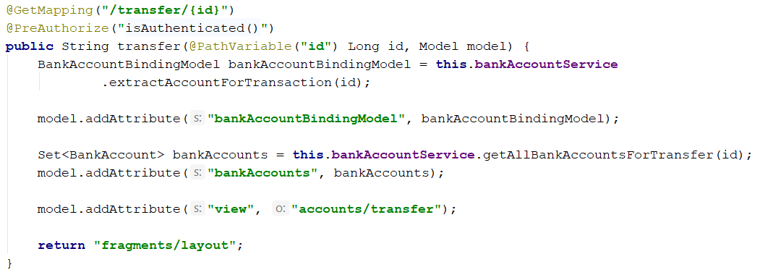

Now, **post**:

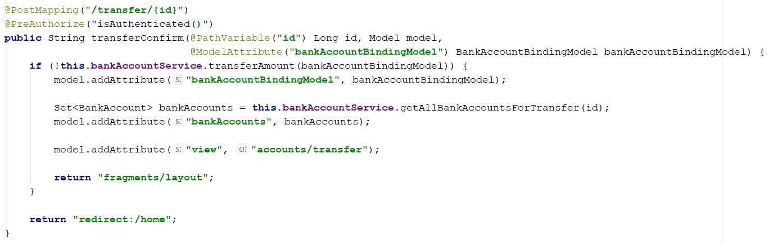

Note that you will need at least **2 accounts** to test the transfer functionality.

## Transactions

In this part we are going to implement the logic for showing a log of all transactions.

### Create TransactionService

In the **services** package create class **TransactionService**. First we need to import our repository by creating a private field and adding it into the constructor. Look at the picture below:

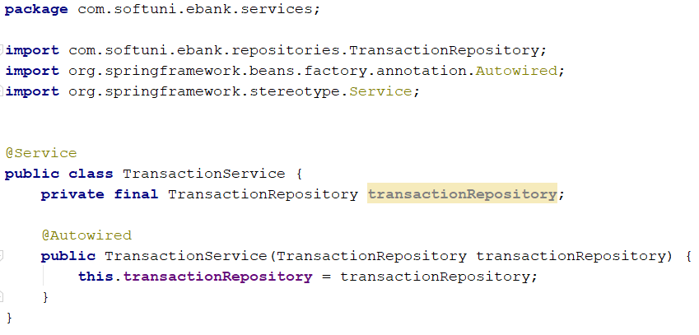

In **TransactionService** create method "getTransactionsByName()" that returns all transactions from the database that our user has sent or received amount of money:

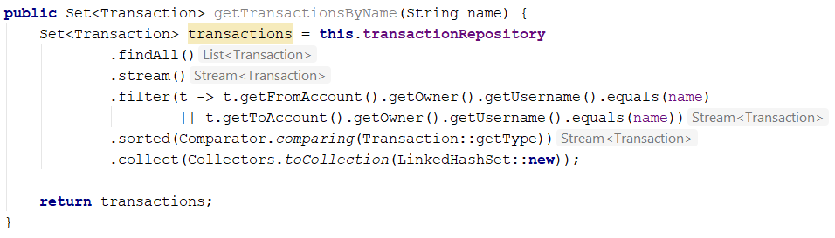

### Edit UserController

Now lets head to "UserController" and import our repository by creating a private field and adding it into the constructor. Look at the picture below:

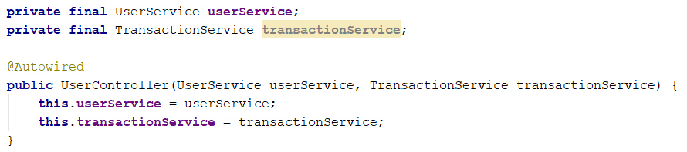

Create a GET method that gets all transactions and send them to our view:

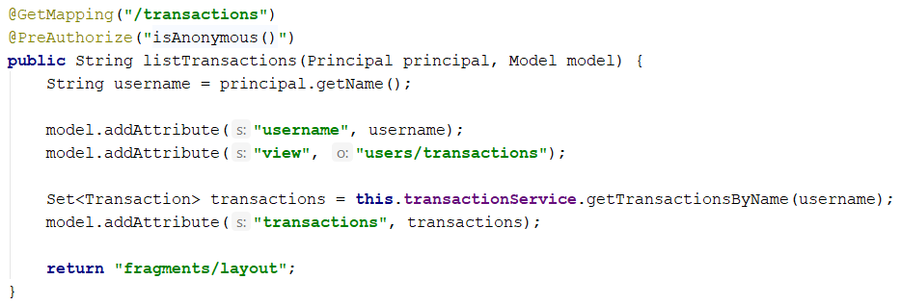

With that we finished our **E-Bank** application. Have fun. ☺